Unit 7:
- Define osmosis , diffusion , hypotonic, isotonic and hypertonic
- Be able to interpret what happens to a cell ( either plant or animal) when placed in hypotonic, isotonic or hypertonic solutions
- Be able to interpret what happens to a dialysis bag when placed in hypotonic, isotonic or hypertonic solutions ( experiment 6.2)
- Be able to identify from a picture whether a cell is turgid, has lysed or plasmolysed (plants in hypertonic solution).
- Identify the movement of solutes or water when a cell is placed in hypotonic, isotonic or hypertonic solutions
- Which molecules can cross a dialysis bag and the indicator used to identify whether a molecule passed or not ( experiment 6.3)
- Know that a dialysis bag and plasma membranes share the characteristic of selective permeability
- What are the factors that affect the diffusion rate ( temperature and size of the molecule)

Chapter 8: Enzymes
- Name the enzyme, the substrate, product and the cofactor?
- What is the effect of Temperature on the enzyme?
- What is the effect of PH?
- What is EDTA and what does it do?
- What do we mean by enzyme specificity?
- What is the dependent and independent variable in these experiments?
Chapter 9: Cellular Respiration
- What are the gasses used to calculate metabolic rate?
- What is unit used for metabolic rate?
- Which animal has a higher metabolic rate a small one or a large one?
- Name the pellets used in the mouse experiment and their function?
- Which type of beans released carbon dioxide boiled or germinated?
- How do we test for the presence of carbon dioxide in a solution?
- Name the tube used in fermentation?
- Which gas did we check to see if fermentation happened or not?

Chapter 10: Photosynthesis
- What is a chromatography paper and why do we use it?
- Name the pigments found in the spinach extract and their color?
- Which pigments were absorbed by the spinach extract and which ones where transmitted? Indicate the color and the wave length.
- Which pigments were absorbed by the carotene extract and which ones where transmitted? Indicate the color and the wave length.
- Which leaf contains starch the covered or the one left in the sun?
- What indicator is used to test for the presence of starch?

Chapter 11: Cell division
- Identify the stages of Mitosis and Meiosis in the picture?
- What is the difference between mitosis and meiosis?
- What is a haploid cell?
- What is a diploid cell?
- When will crossing over take place?
- 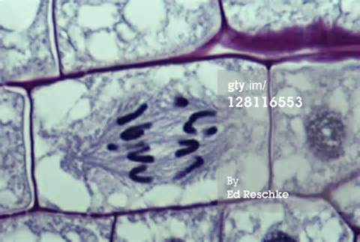
- 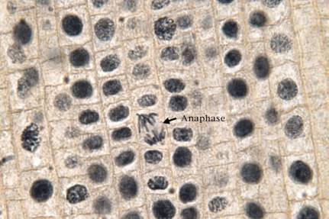
- 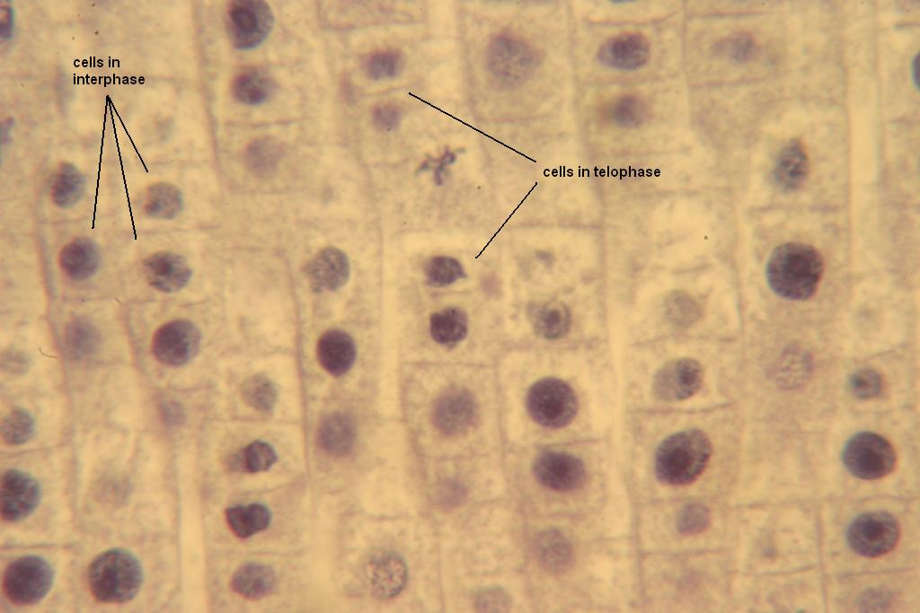
- 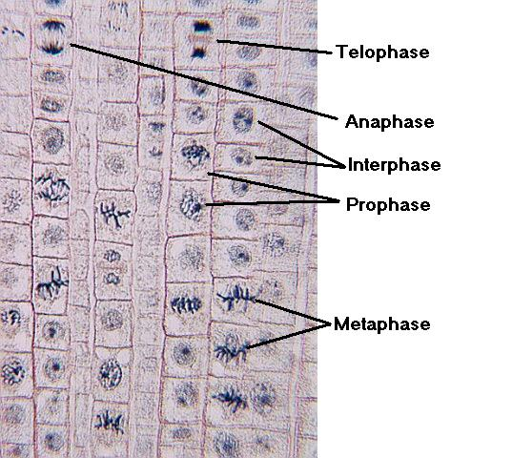
- 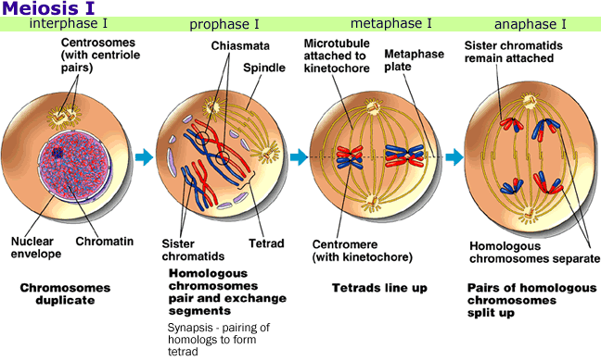
- 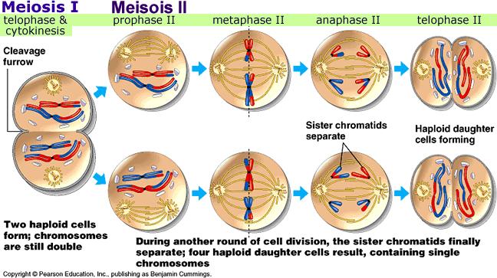

Biotechnology
- Blood type
- What charge is found on the DNA?
- Be able to read a gel
- Why do we use the meat tenderizer, the soap and the ethanol in the extraction of DNA?

